(Approx. 933 words)

Are You Safe from a Cyber Attack?
By Lou Torraca, President, The TUG-MOAA User Group, Hawaii
President@the-TUG.org
www.the-tug.org
Around Hawaii - Oceanic Time Warner Cable's Community Website
http://www.aroundhawaii.com/lifestyle/computers/

I always enjoy reading the “what happened in history” emails I get about once a month, so I was reminded that September had a profound effect on the way we treat our personal technology.

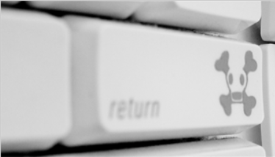
HackerOn September 18, 2001, a new virus attacked United States operating systems. The worm was given the name Nimda, and it was an advanced version of Code Red II. Some might say that the Code Red viruses were created in preparation for the much larger Nimda attack, which was executed the week following the attacks on the World Trade Center and Pentagon. Due to the release date of the virus, members of the American government speculated on a link between the cyber-attacks and Al Qaeda, but this theory ended up proving unfounded. The American media did not report much on the virus because of the terrorist attacks.

Multiple propagation vectors allowed Nimda to become the Internet’s most widespread and dangerous virus. It took only 22 minutes for the worm to rip through the American financial sector, causing over $3 billion in damage. The Nimda virus was so effective because it used five different infection vectors. People could, and still can, get the virus via e-mail, open network shares, infected websites, exploitation, or via back doors left behind by the Code Red II virus. The group of people behind the Nimda virus and the theft of billions of dollars are unknown. The event greatly damaged the world’s financial sector and economy.

There are numerous places you can review various ways to protect yourself, e.g. my last column listed free programs you can download to block viruses and malware. One government agency that has excellent advice is Homeland Security. Here is the page on their website that offers suggestions on how to protect yourself from Cyber Attacks:

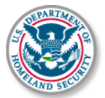
What You Need To Know

The Department of Homeland Security plays an important role in countering threats to our cyber network. We aim to secure the federal civilian networks, cyberspace and critical infrastructure that are essential to our lives and work.

DHS’s National Cybersecurity and Communications Integration Center (NCCIC) is a 24x7 center responsible for the production of a common operating picture for cyber and communications across the federal, state, and local government, intelligence and law enforcement communities and the private sector.

Next Steps

The following preventative strategies are intended to help our public and private partners proactively look for emails attempting to deceive users into "clicking the link" or opening attachments to seemingly real websites:

- Never click on links in emails. If you do think the email is legitimate, whether from a third party retailer or primary retailer, go to the site and log on directly. Whatever notification or service offering was referenced in the email, if valid, will be available via regular log on.
- Never open the attachments. Typically, retailers will not send emails with attachments. If there is any doubt, contact the retailer directly and ask whether the email with the attachment was sent from them.
- Do not give out personal information over the phone or in an email unless completely sure. Social engineering is a process of deceiving individuals into providing personal information to seemingly trusted agents who turn out to be malicious actors. If contacted over the phone by someone claiming to be a retailer or collection agency, do not give out your personal information. Ask them to provide you their name and a call-back number. Just because they may have some of your information does not mean they are legitimate!

Other practical tips to protect yourself from cyber-attacks:

- Set secure passwords and don't share them with anyone. Avoid using common words, phrases, or personal information and update regularly.
- Keep your operating system, browser, anti-virus and other critical software up to date. Security updates and patches are available for free from major companies.
- Verify the authenticity of requests from companies or individuals by contacting them directly. If you are asked to provide personal information via email, you can independently contact the company directly to verify this request.
- Pay close attention to website URLs. Pay attention to the URLs of websites you visit. Malicious websites sometimes use a variation in common spelling or a different domain (for example, .com instead of .net) to deceive unsuspecting computer users.

Tips

Most people use passwords that are based on personal information and are easy to remember. However, that also makes it easier for an attacker to guess or "crack" them.

Although intentionally misspelling a word ("daytt" instead of "date") may offer some protection against dictionary attacks, an even better method is to rely on a series of words and use memory techniques, or mnemonics, to help you remember how to decode it.

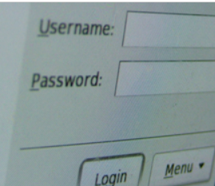
For example, instead of the password "hoops," use "IlTpbb" for "[I] [l]ike [T]o [p]lay [b]asket[b]all." Using both lowercase and capital letters adds another layer of obscurity. Your best defense, though, is to use a combination of numbers, special characters, and both lowercase and capital letters. Change the same example we used above to "Il!2pBb." and see how much more complicated it has become just by adding numbers and special characters.

The website (http://www.dhs.gov) also has links to other pages that have good advice regarding security, as well as other pertinent issues; I suggest you take a look.

That’s it for now, be safe out there. Follow the above advice, but save time to have some fun too.

Aloha, Lou

